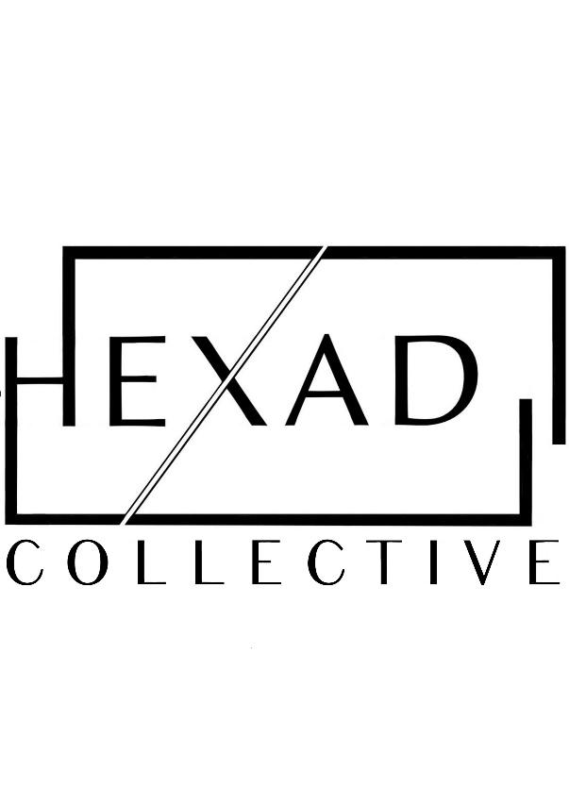

‘Caged Byrd’: 5 Catholic Feasts through Spring and Summer
Easter
‘Kyrie and Gloria’ from Mass for 3 Voices (William Byrd)
Terra Tremuit (Byrd)
O Taste and See (Piers Kennedy)

Ascension
Ascendit Deus in Jubilatione (Byrd)
Ad te, Domine (Anna Semple)

Pentecost
Ah, Robyn (William Cornysh) // Thou Shalt Know (Anna Semple)
Spiritus Domini (Byrd)

St Peter and St Paul
‘Sanctus and Benedictus’ from Mass for 3 Voices (Byrd)
Tu es Pastor Ovium (Byrd)
‘Tu es Petrus’ from St Peter’s Triptych (Kennedy)

Assumption
Assumpta est Maria (Byrd)
Magnificat from ‘Worcester Canticles’ (Kennedy)
‘Agnus Dei’ from Mass for 3 Voices (Byrd)

